Start Running with Potters Trotters
First session: Tuesday 8th September 2015 from 6pm (after that arrive to start running at 6.30pm every Tuesday and Thursday)
Location: Brindley Building Foyer, Staffordshire University Leek Road Campus
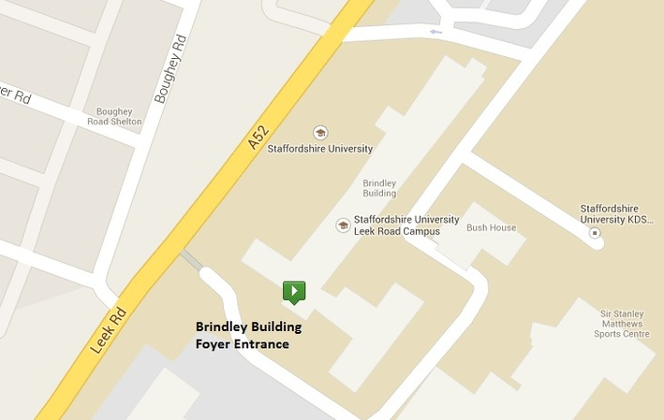
Approach: we build up slowly using a run/walk technique to get everyone running for 40 minutes or more without stopping during the course.
Running routes: we’ll run along the canal towpath, in parks, along pavements and around the university campus. We may run on grassy areas too.
Goal: at the end of the course, why not sign up for a race or take part in parkrun – we encourage the group to enter an event together to celebrate their achievement. If you’ve got a specific running goal, we can help you achieve it.
Current fitness: you don’t need to have done any running at all but need to be able to walk for 30 minutes comfortably. If you’re already able to run for 30 minutes, get in touch to find out about joining us for a trial run.
Ethos: Run at your own pace. No one is left to run on their own. Support and encouragement - other club members will run with the beginners group to offer advice and keep you company.
Beginners’ sessions organised by club members who have completed the Leadership in Running Fitness course from England Athletics.
Social: stay for a drink after your run – coffee machines in the Brindley Foyer (organised event on the first Tuesday of every month)
Make new friends: get together at weekends to complete a weekly running challenge.
To take part: suitable footwear and clothing (including sports bra)
Fee: £20 for 10 week course (includes club membership until March 2016)
Benefits of club membership: support from club members, advice on races, kit and other aspects of running, help with training plans, link with England Athletics, race and other discounts, weekend running groups
Contact: potterstrottersstokeontrent@gmail.com for more information and to sign up.
Find out about the club on our website: http://potterstrotters.weebly.com/ or on Facebook: https://www.facebook.com/PottersTrottersStokeonTrent
Read stories from some of our runners: http://potterstrotters.weebly.com/news-views-and-reviews/a-beginners-journey
FAQs: http://potterstrotters.weebly.com/news-views-and-reviews/faqs-for-beginners

